**Chapter 1**

**INTRODUCTION**

A database is an organized collection of data. A relational database, more restrictively, is a collection of schemas, tables, queries reports, views, and other elements. Database designers typically organize the data to model aspects of reality in a way that supports processes requiring information, such as (for ex) modelling the availability of rooms in hotels in a way that supports finding hotel with vacancies.

A database-management system (DBMS) is a computer-software application that interacts with end-user, others applications, and the database itself to capture and analyse data. A general-purpose DBMS allows the definition, creation, querying, update, and administration of databases. Well known DBMS include MySQL, PostgreSQL, Enterprise DB, MongoDB, MariaDB, Microsoft SQL server, oracle, Sybase, Sap, HANA, SQLite and IBM DB2.

A database is not generally across different across DBMs, but different DBMs can interoperate by using standards such as SQL and ODBC or JDBC to allow a single application to work with more than one DBMS. Computer scientists may classify database-management systems according to the database models that they support the most popular database systems since 1980s have all supported the relational model – generally associated with the SQL language. sometimes a DBMs is loosely referred to as a “database”.

* 1. **About Database Management System**

In the 1970s and 1980s, attempts were made to build database systems with integrated hardware and software. The underlying philosophy was that such integration would provide higher performance at lower cost. Examples were IBM system/38, the early offering of tera data, database machine C. **Wayne Ratliff** the creator of dBase stated: “dBase was different from programs like BASIC, C, FORTRAN, and COBOL in that a lot of the dirty work had already been done. The data manipulation is done by DBASE instead of by the user can concentrate on what he is doing, rather than having to mess with the dirty details of opening, reading and closing files and managing space allocation,” DBASE was one of the top selling software titles in the 1980s and early 1990s.

**1.2 Advantages of DBMS**

Databases are used to support internal operations of organization and to underpin online interactions with customers and suppliers.

Databases are used to hold administrative information and more specialized data, such as engineering data or economic models. Examples of database application include computerized library systems, flight reservation Systems, computerized parts in inventory systems, and many content management systems that store websites as collections of Web Pages in a database.

* 1. **Application on Databases Management System**

A Databases Management System is a computerized record-keeping system. It is a repository or a container for collection of computerized data files. The overall purpose of DBMS is to allow the users to define, store, retrieve and update the information contains in the database on demand. Information contained in the database on demand. Information can be anything that is of significance to an individual or organization.

Some of the following are the uses of DBMS:

1. Effective and efficient management of data
2. Query processing and management
3. Easy to understand and user friendly
4. Security and integrity of data
5. Data sharing and storage
   1. **Introduction to SQL**

**SQL Structured query Language** is a domain- specific language used in programming and designed for managing data held in a relational database management system (RDBMS), or for stream processing in a relational data stream processing in a relational data stream management system (RDBMS).

SQL devices in several ways from its theoretical foundation, the relational model and its tuple calculus. In that model, a table is a set of tuples, while in SQL, tables and query results are list of rows the same may occur multiple times, and the order of rows can be employed in queries (e.g., in the LIMIT clause).

Originally based upon relational algebra and tuple relational calculus, SQL consists of a **data definition language, data manipulation language,** and **data control language.** The scope of SQ includes data insert, query, update and delete, Schema creation and modification, and data access control. Although SQL is often described as, and to a great extent is, a declarative language, it also includes procedural elements.

The four main categories of SQL statements are as follows:

1. DML (data Manipulation Language)
2. DDL (Data Definition Language)
3. DCL (Data Control Language)
4. TCL (Transaction Control Language)

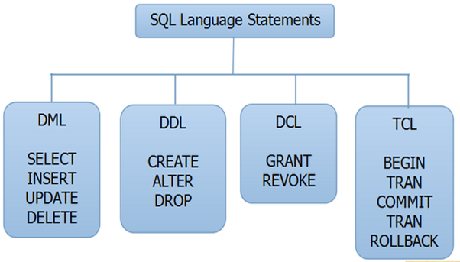

* 1. **DML (Data Manipulation Language)**

DML statements affect records in table. These are basic operations we perform on data such as selecting a few records from a table, inserting new records. deleting unnecessary records, and updating/modifying existing records.

DML statements include the following:

**SELECT**– select records from a table

SYNTAX:

SELECT * FROM <TABLENAME>

**INSERT**  - insert new records

SYNTAX:

INSERT INTO**<table name> values (value1, value2, value3…);**

**UPDATE**- update/modify existing records

SYNTAX:

Table_ name SET column_ name = value [column_ name= value....] [WHERE condition]

**DELETE** - delete existing records.

SYNTAX:

DELETE FROM table_ name [WHERE condition];

* 1. **DDL (Data Definition Language)**

DDL statements are used to alter/modify a database or table structure and schema. These statements handle the design and storage of database objects.

**CREATE -** create a new Table, database, and schema

SYNTAX:

CREATE TABLE [table name] ([column definitions]) [table parameters];

**ALTER** – alter existing table, column description

SYNTAX:

ALTER object type, object name parameters;

**DROP -**delete existing objects from database

SYNTAX**:** DROP Table<table name>;

* 1. **DCL (Data Control Language)**

DCL statements control the level of access that users have on database objects.

**GRANT** – allow the users to read /write on certain database objects.

**REVOKE**- keeps users from read/write permission on database objects.

* 1. **TCL (Transaction Control Language)**

TCL statements allow you to control and manage transactions to maintain the integrity of data within the SQL statements

**BEGIN** Transaction-opens a transaction

**COMMIT** Transaction-commits a Transaction

**ROLLBACK** Transaction- ROLLBACK a Transaction in case of any error

* 1. **Introduction to blood bank management system**

The Database will contain the tables which will have the various contents related to Blood bank it involves the information about blood storage and management.

Blood banks collect, store, and provide blood. Typically, these banks collect blood from voluntary blood donors. The banks then sort blood by type, check blood to make sure it is free of disease and then store it for future use. The main mission of a [blood](https://www.bartleby.com/topics/blood) bank is to provide life-saving blood to hospitals and other health care facilities.

The term “blood bank” refers to a division of a hospital laboratory where the storage of blood product occurs and where proper testing is performed to reduce the risk of transfusion related events. Blood Bank Management System is a system that can assists the information of blood bag during its handling in the blood bank.

It contains all the information about blood, blood group, blood doner, where the blood is stored etc…

**Advantages:**

1. one can get rid from manual procedure. Now they to do the entries in the information system.

2. one can get the list of donors address wise; blood group wise if the desired blood group is not available in the central inventory.

3. one can get the information of the particular blood group available in the blood bank.

4. Information retrieval will be precise and effective.

**Chapter 2**

**REQUIREMENT SPECIFICATION**

**2.1. Hardware requirements:**

It captures the complete hardware requirements for the system or a portion of the system. These requirements include the minimum processor speed, memory, and disc space required to install windows. In almost all cases, you will want to make sure that your hardware exceeds these requirements to provide adequate performance for the services and applications running on the server.

Processor: Intel core processor

RAM: 512 MB and above

Hard-disc: 2 GB and above

**2.2. Software requirements:**

**Software requirements:**

Operation system: windows 10

Front end: HTML, CSS

IDE: BRACKETS

Back end: PHPMYADMIN

Programming language: SQL

Server: Apache.

**Chapter 3**

**System Design**

**3.1 E-R DIAGRAM:**

An entity relationship (ER MODEL) describes inter-related things of interest in a specific domain of knowledge. An ER model is composed of entity types and specify relationships that can exists between instances of those entity types. Fig 3.1 shows the ER diagram of blood bank management system.

­­­­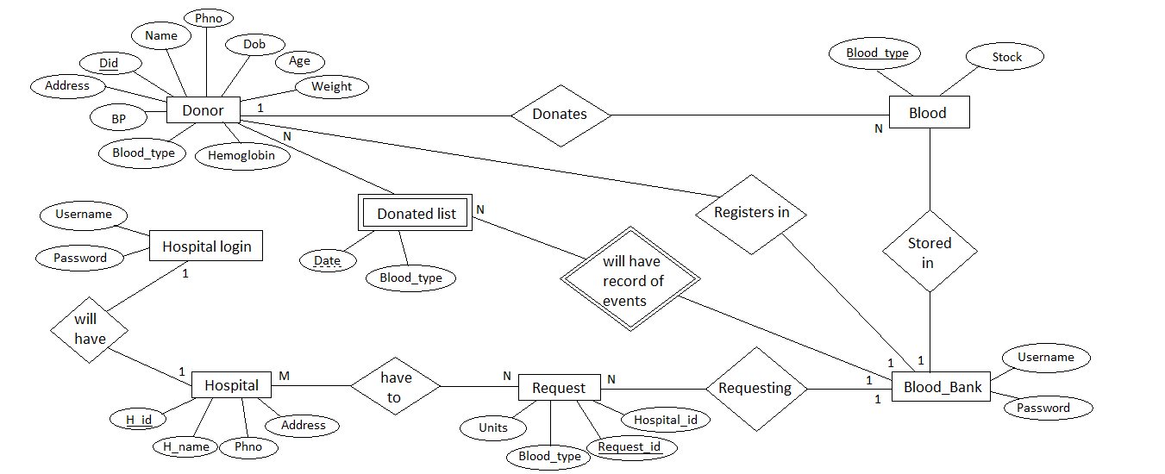Fig 3.1­­­­

**3.2. Logical Schema**

A database schema is the skeleton structure that represents the logical view of the entire database. It defines how the data is organized and how the relations among then are associated. It formulates all the constraints that are to be applied on the data.

A database schema defines its entities and the relationship among them. It contains a descriptive detail of the database, which can be depicted by means of schema diagram. It’s the database designers who design to help programmers understand the database and make it useful. Fig 3.2 shows the logical schema of the blood bank management system

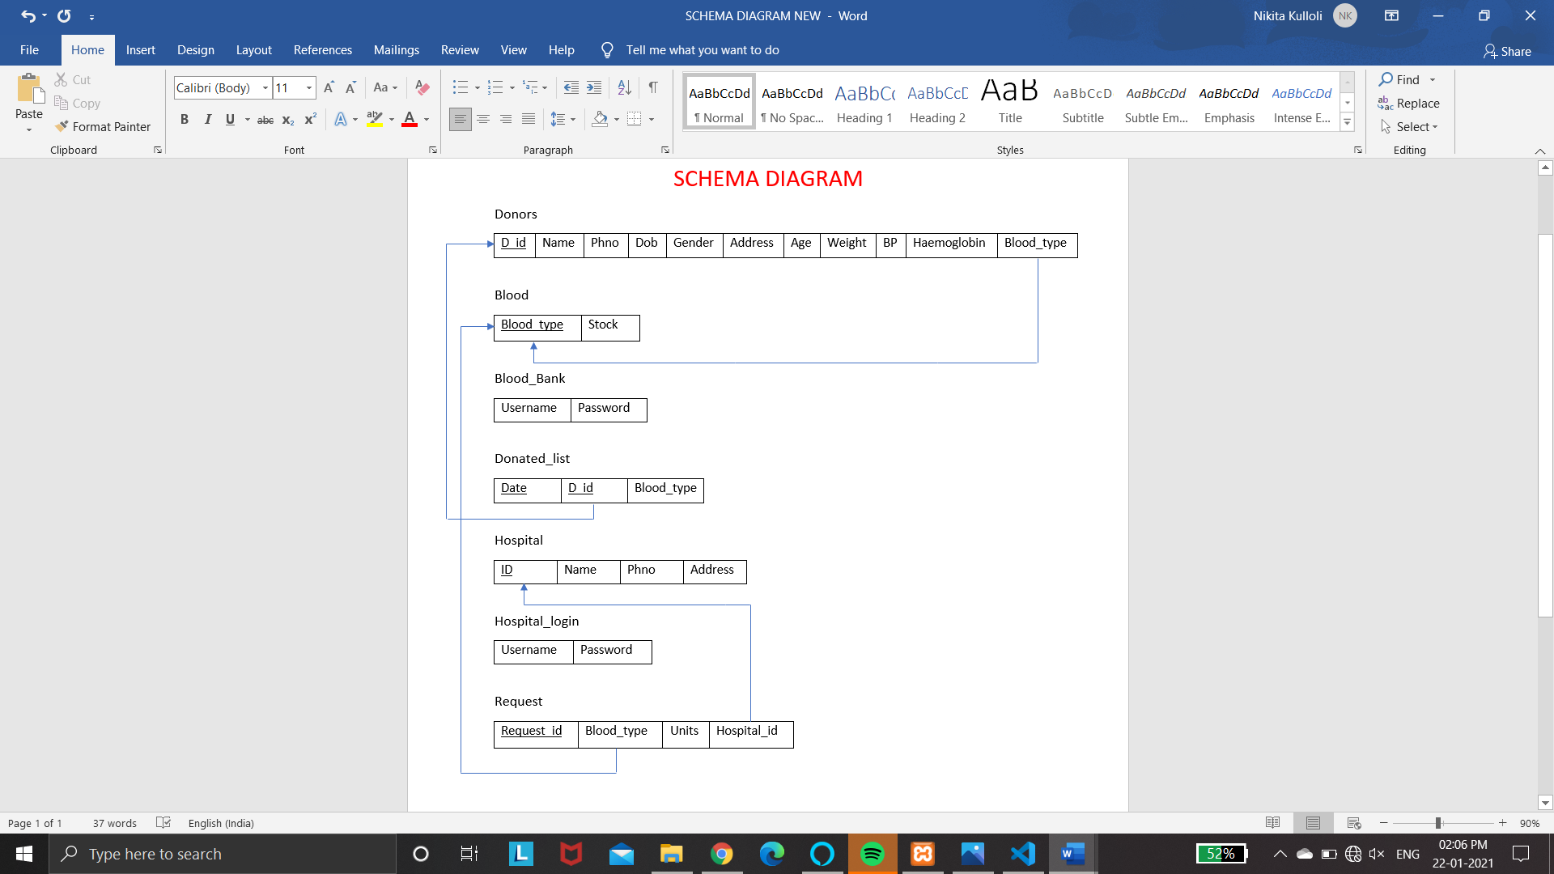Fig 3.2

**Chapter 4**

**IMPLEMENTATION**

The special methods used in the project are explained:

**4.1. Triggers:**

A trigger is a named database object that is associated with a table, and that activates when a particular event occurs for the table. Some uses for triggers are to perform checks of values to be inserted into a table or to perform calculations on values involved in an update.

A trigger is defined to activate when a statement inserts, update, or delete rows in the associated table. These row operations are trigger events. For example, rows can be inserted by INSERT OR LOAD DATA statements, and an insert trigger activates for each inserted row. A trigger can be set to activate either before or after the trigger event. For example, you can have a trigger activate before each row that is inserted into a table or after each row that is updated.

The trigger used in the project is a after delete trigger. In this trigger we are delete a old row in the branch table immediately after that inserts a new row in delete branch table.

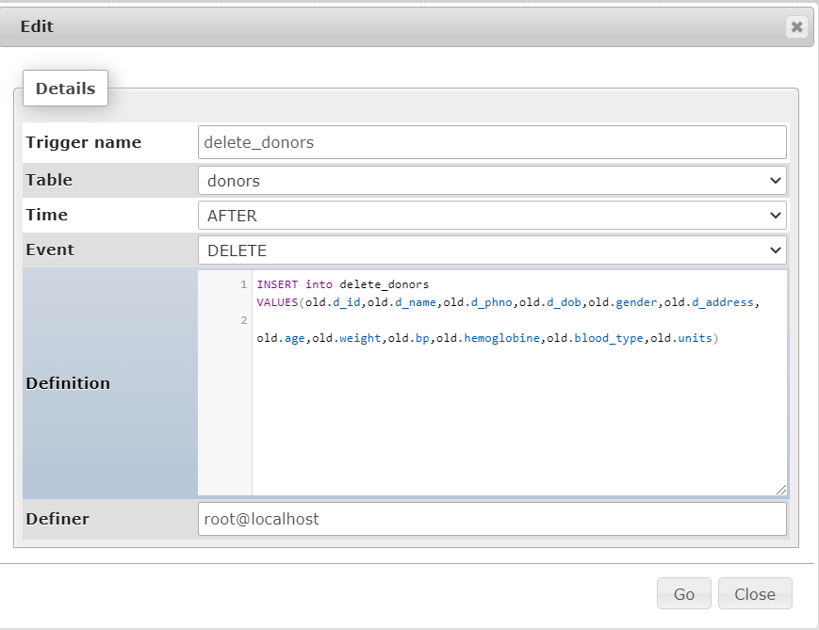

**4.2 Stored Procedure:**

A procedure is a subroutine like a subprogram in a regular computing language, stored in database. A procedure has a name, a parameter list, and SQL statement.

The major difference is that UDFs can be used like any other expression within the SQL statements, whereas stored procedure must be invoked using a call state.

1. DELIMITER //

BEGIN

SELECT * FROM donors;

END

1. DELIMITER //

BEGIN

SELECT * FROM donated_list;

END

1. DELIMITER //

BEGIN

SELECT * FROM hospital;

END

**Chapter 5**

**Testing**

**5.1. Introduction to Testing**

Software testing is an investigation conducted to provide stakeholders with information about the quality of the software product or service under test. Software testing can also provide an objective, independent view of the software to allow the business to appreciate and understand the risks of software implementation. Test techniques include the process of executing a program or application with the intent of finding software bugs (errors or other defects), and verifying that the software product is fit for use.

|  |  |  |  |  |  |  |
| --- | --- | --- | --- | --- | --- | --- |
| Test case id | Test case | Input data | Steps to execute the test case | Expected Result | Actual Result | Pass/Fail |
| **1** | Login screen | Wrong username or password. | After entering the data click the login button. | A proper message indicating the error should appear and the user should be redirected to login screen. | A message was displayed saying invalid username or password. | Pass |
| **2** | Insertion | If field not entered. | After entering the data, click the insert button | A proper message indicating the error should appear and the user should be redirected to insertion screen. | A message pointing to the respected field showing that this field is required. | Pass |
| **3** | Deletion | **-** | After clicking the delete button. | Particular row is deleted. | Row is deleted. | Pass |
| **4** | Edit | If field not entered. | After clicking the edit button. | A proper message indicating the error should appear and the user should be redirected to update screen. | A message pointing to the respected field showing that this field is required. | Pass |

**5.3. SNAPSHOTS**

Common Page:

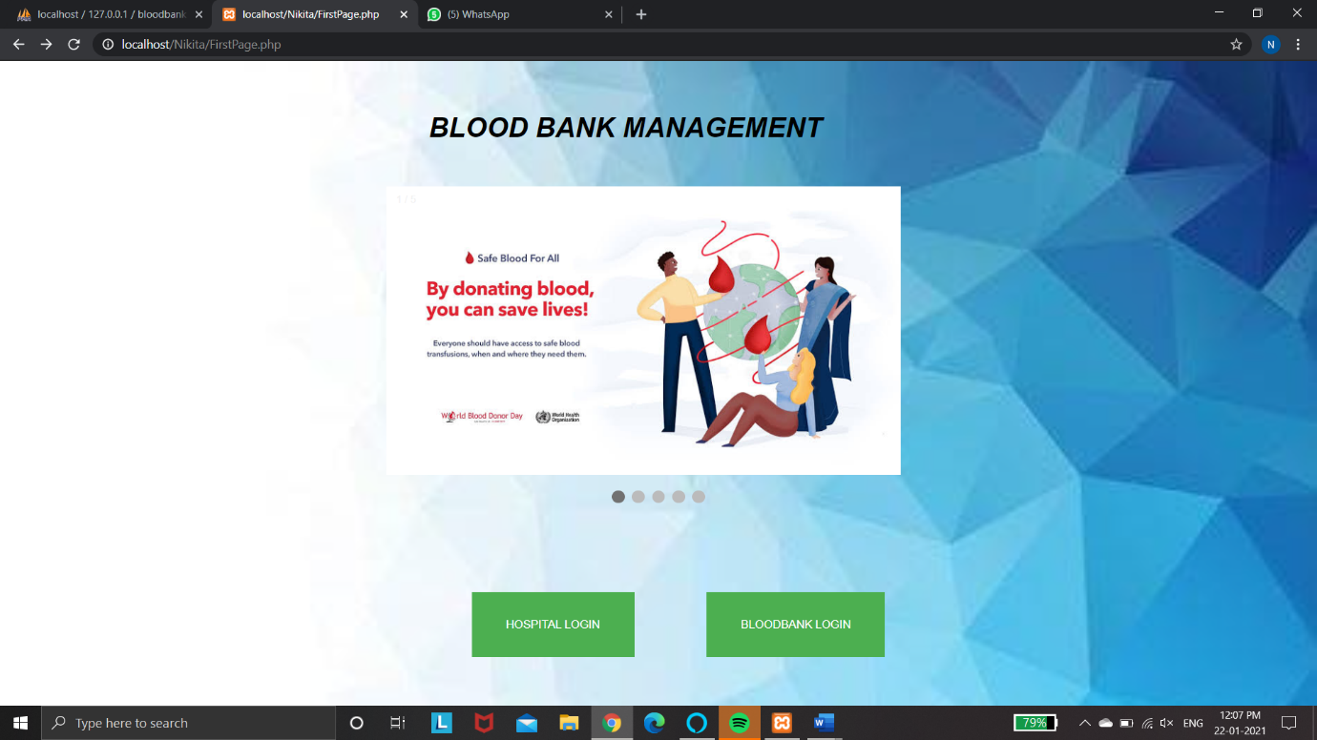

Blood bank login page: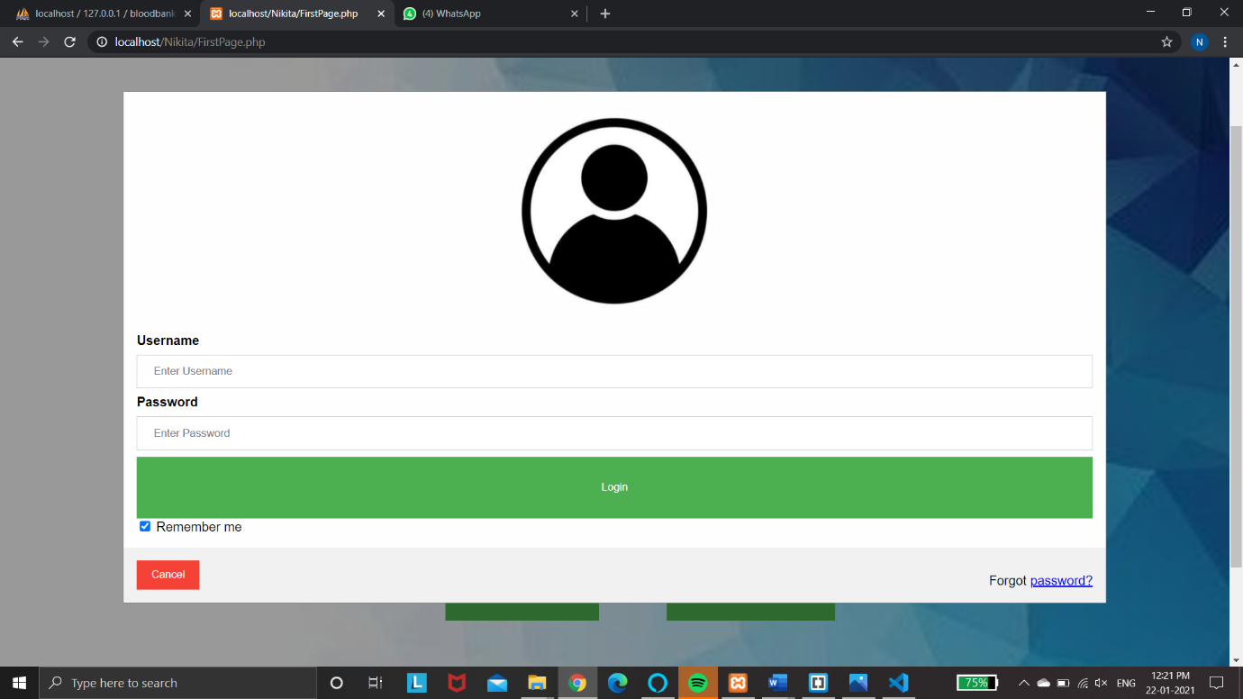

Menu page to select the particular entity:

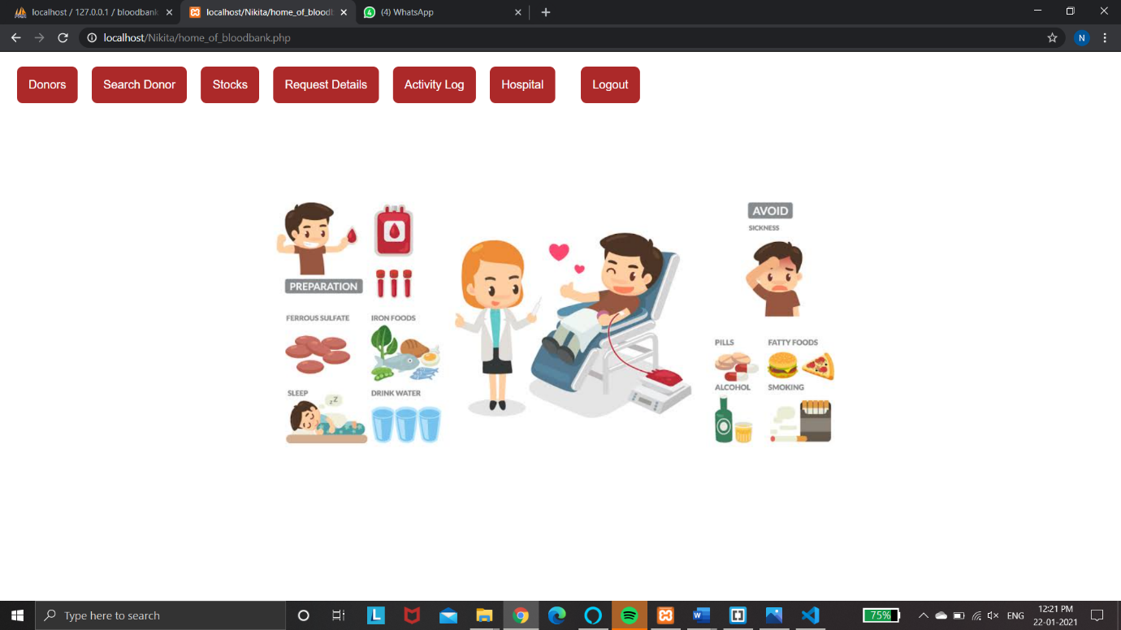

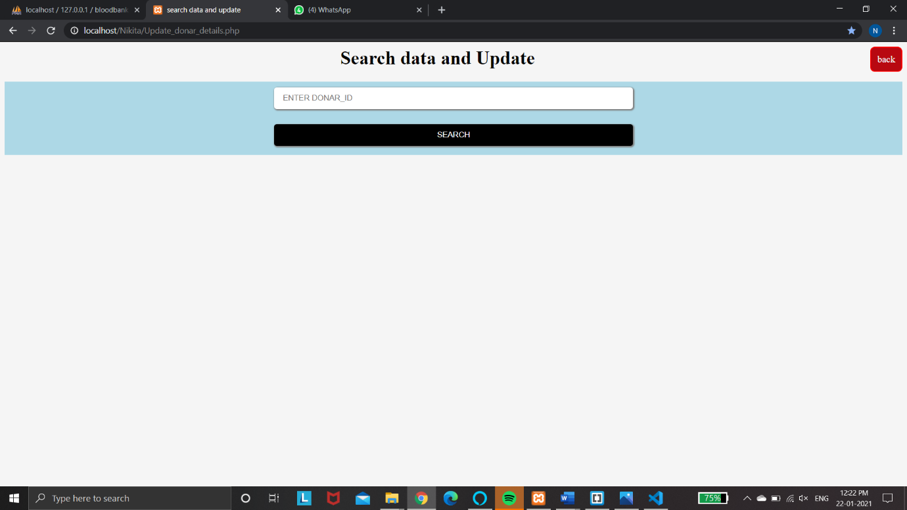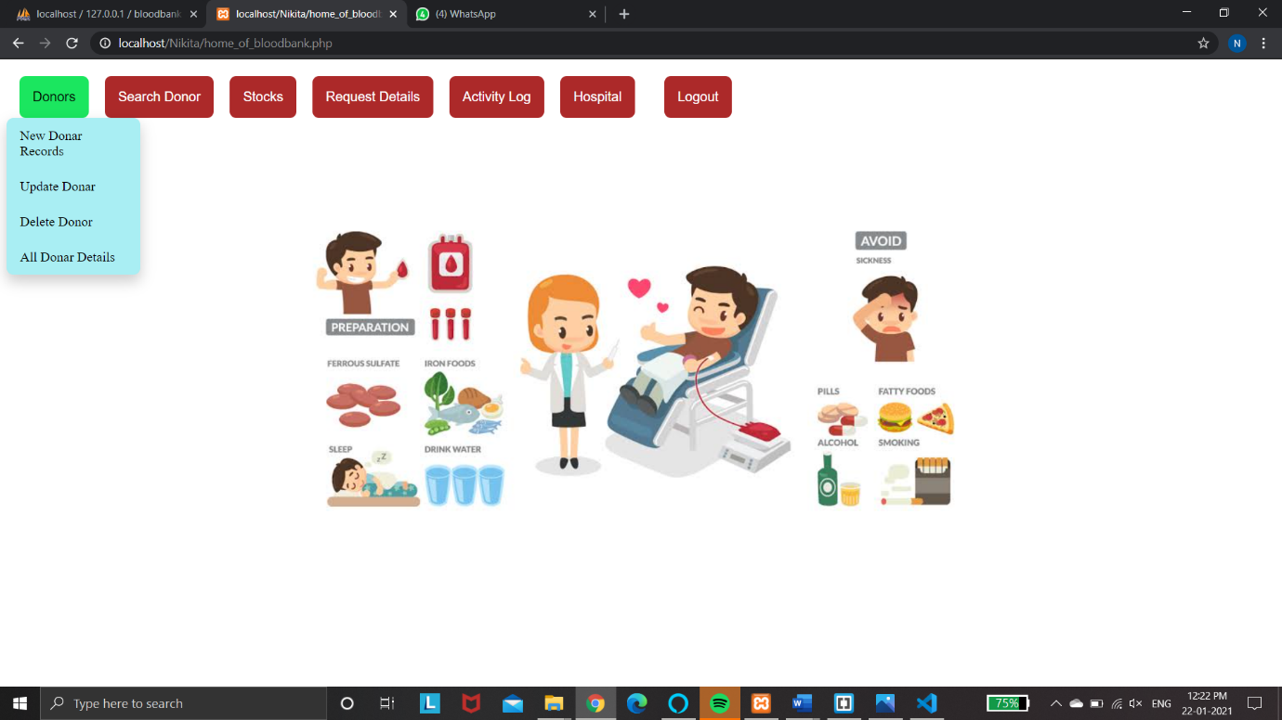To add, update, delete and view donors:

To add new details:

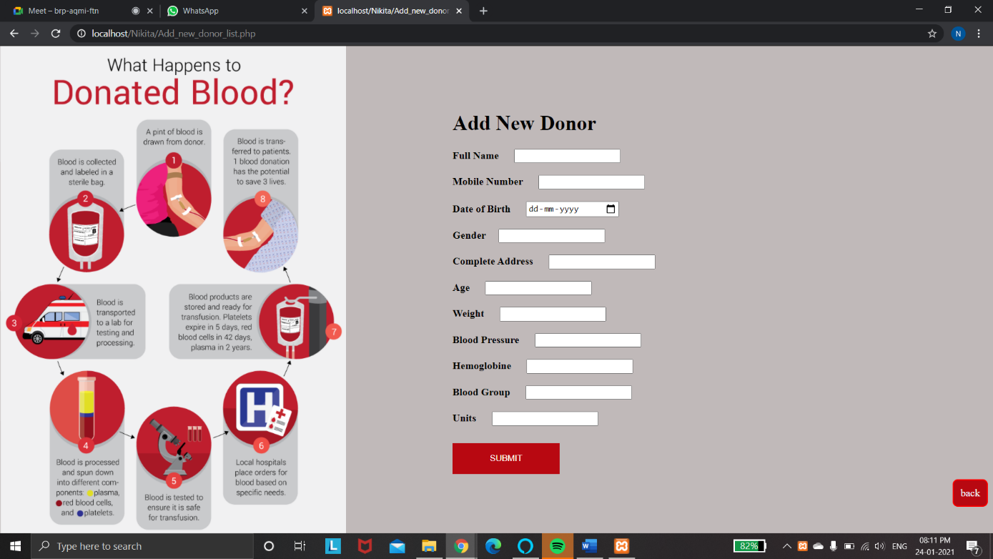

Update:

To delete Donor:

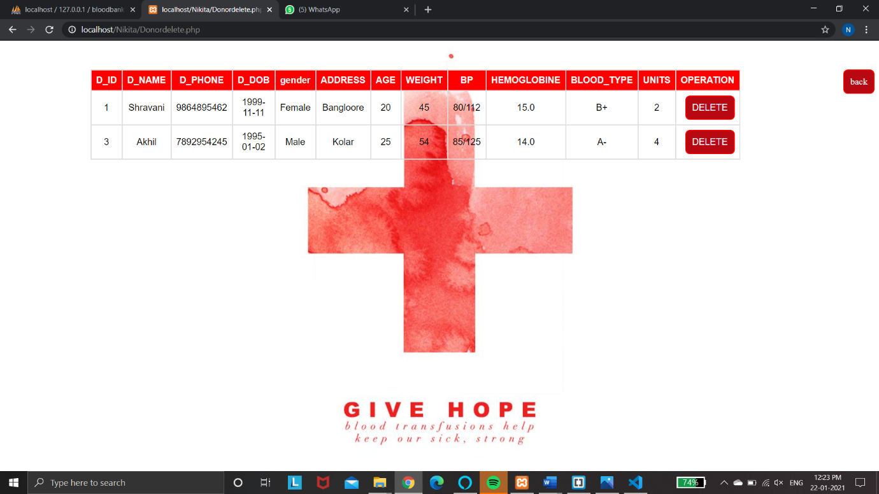

To view:

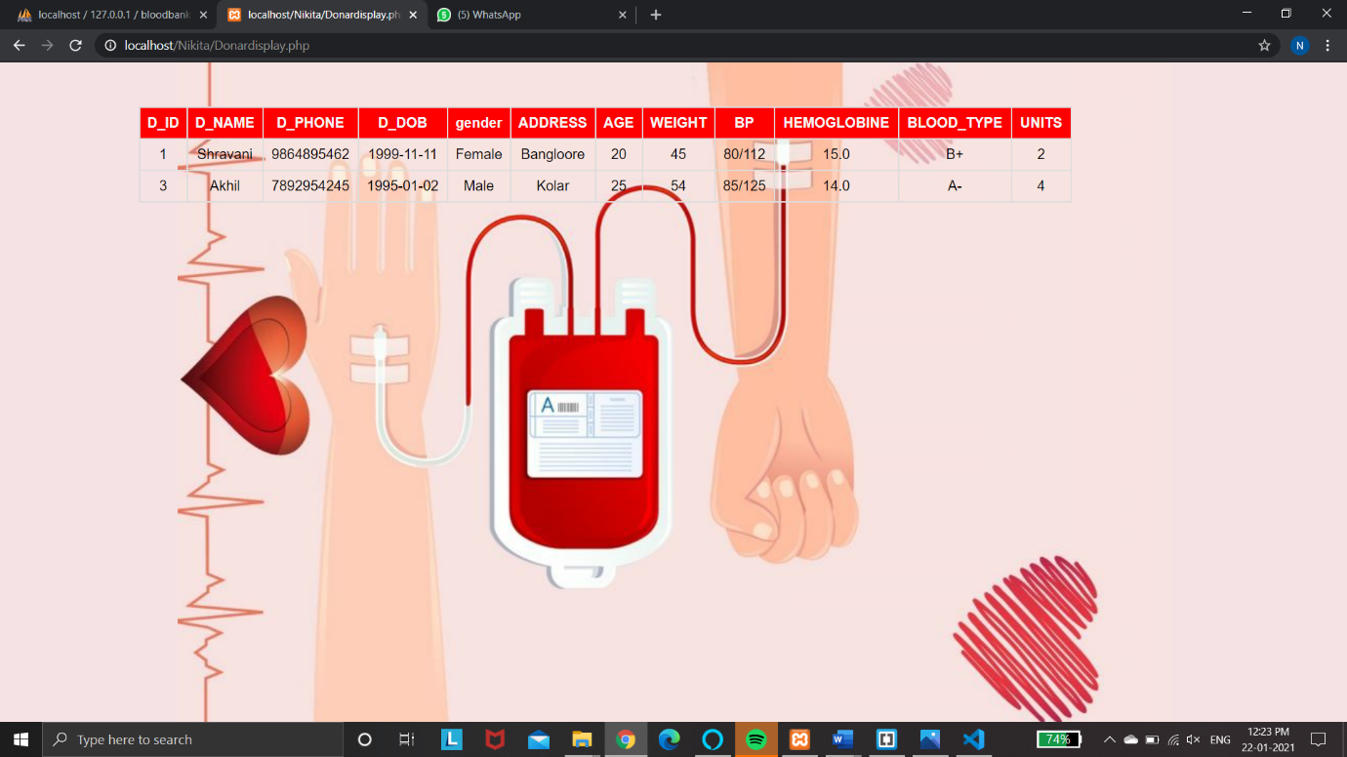

To search donors:

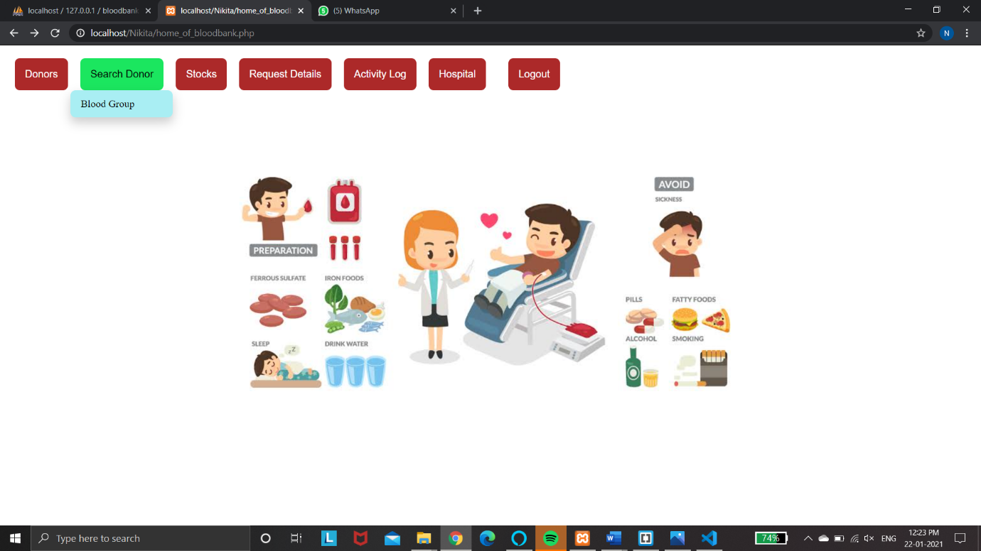

To search donors by blood types:

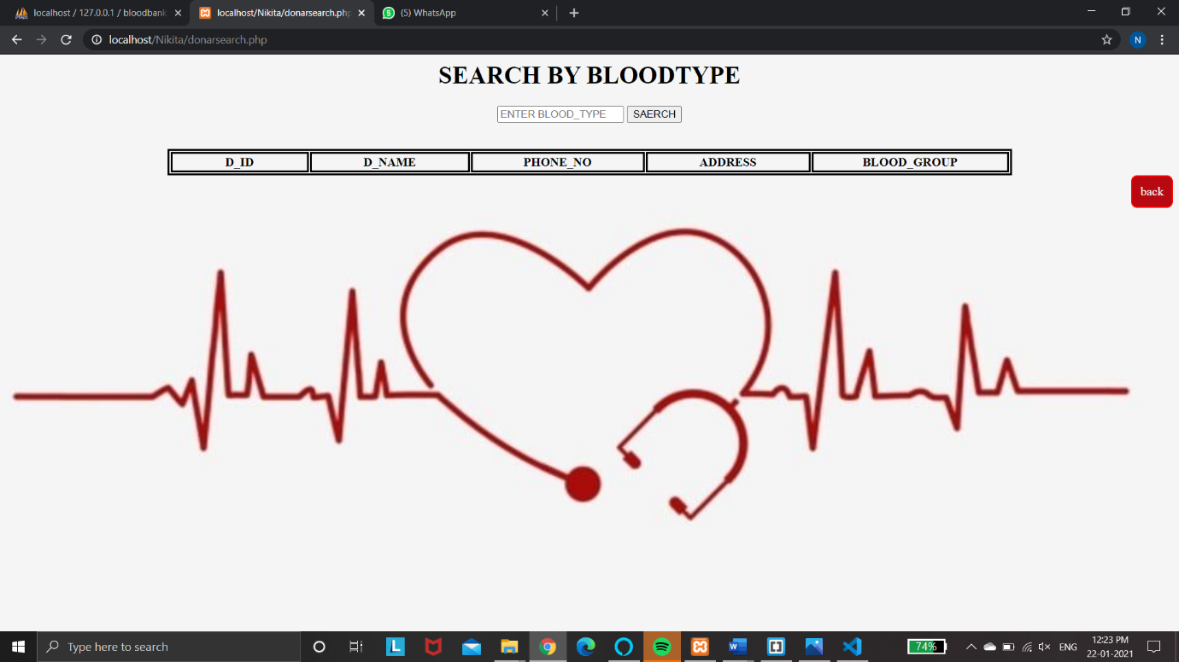

Stocks details:

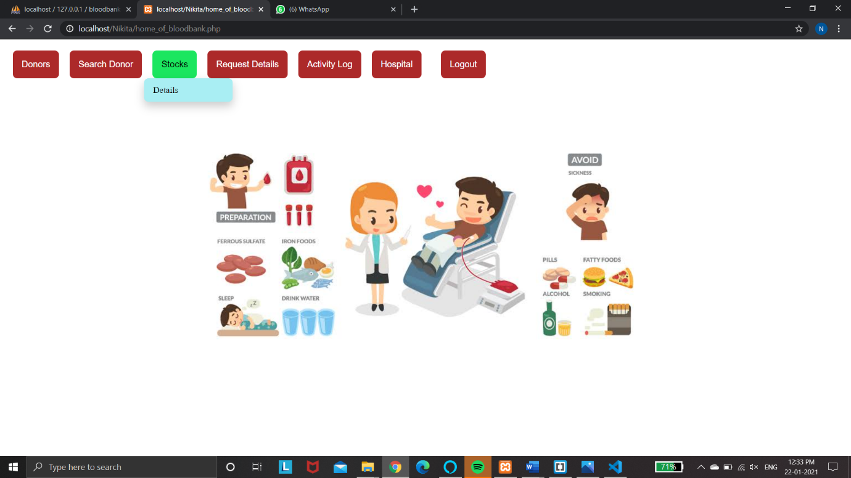

Displaying Stocks details:

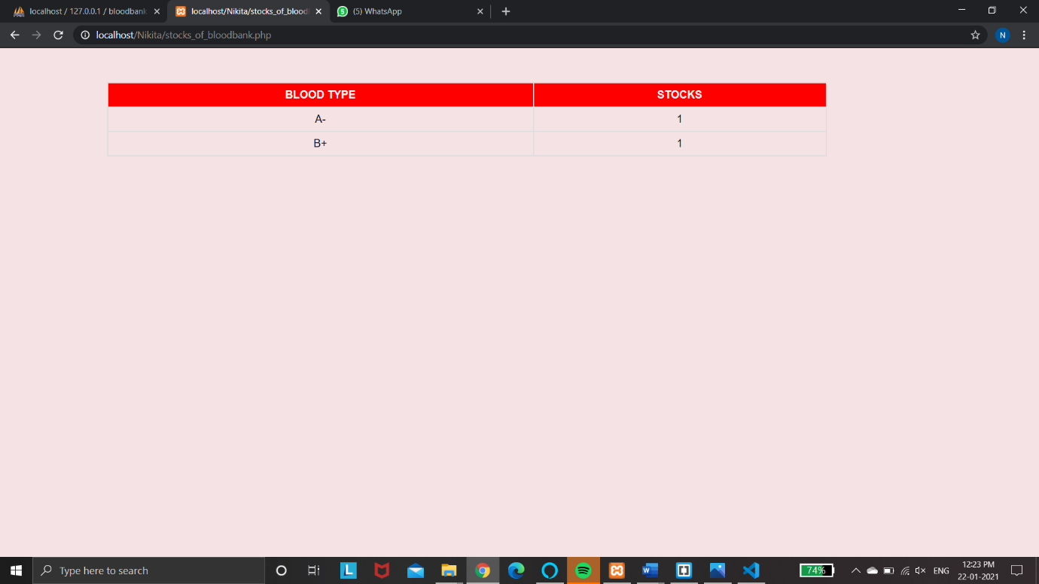

Request Details:

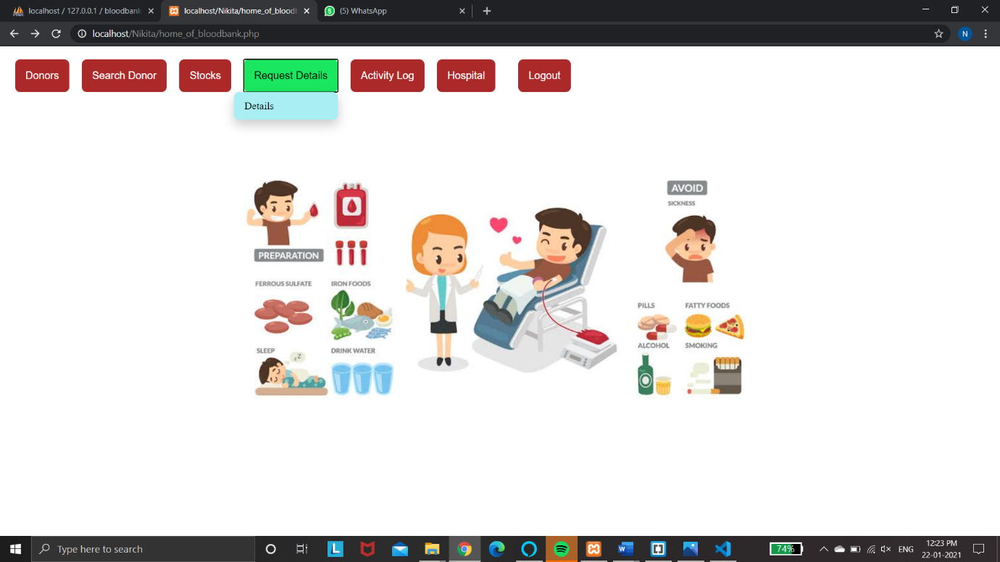

Requests from hospital:

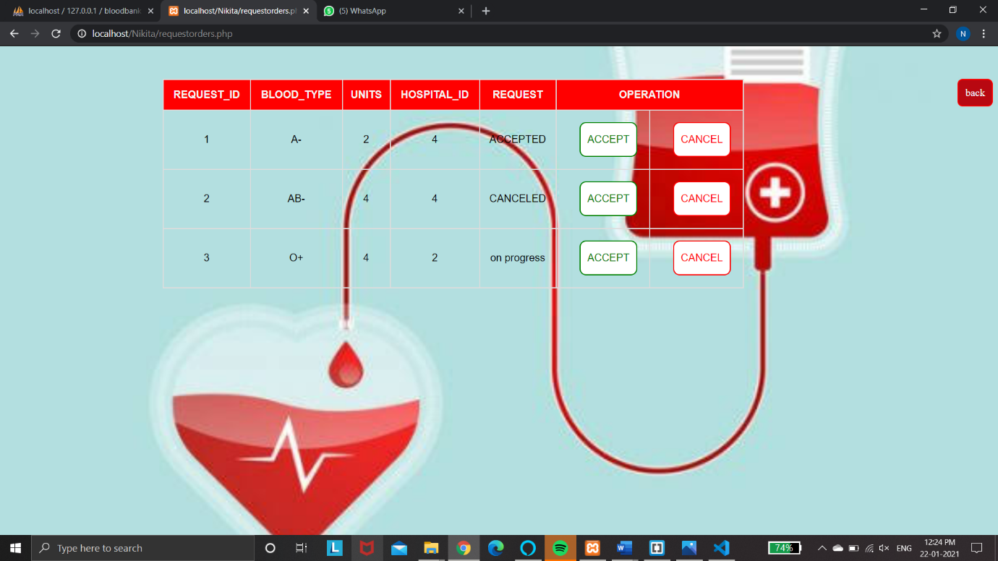

Activity log:

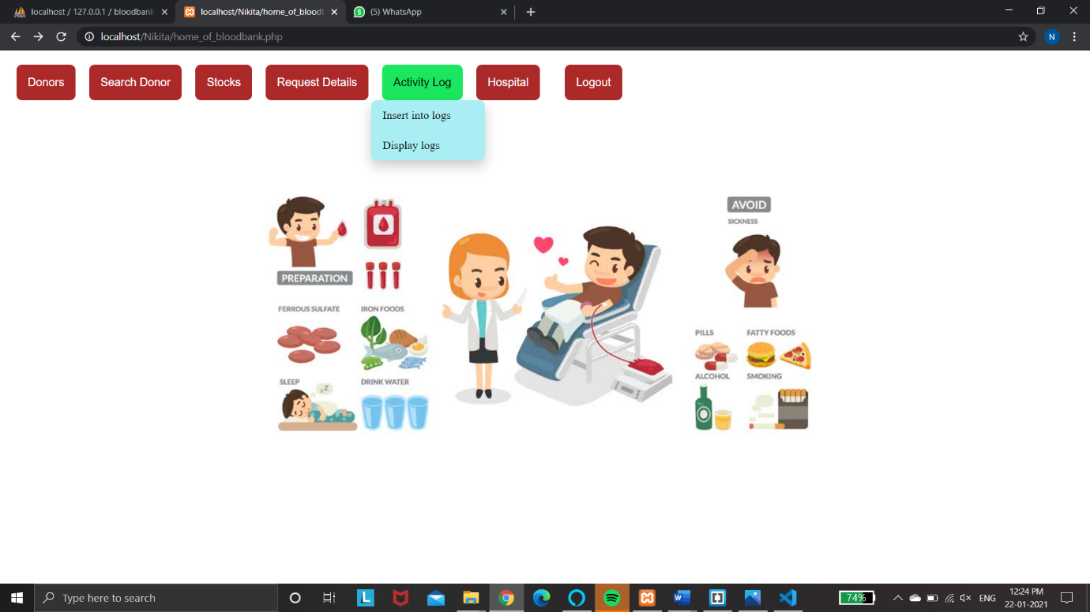

Insert log details:

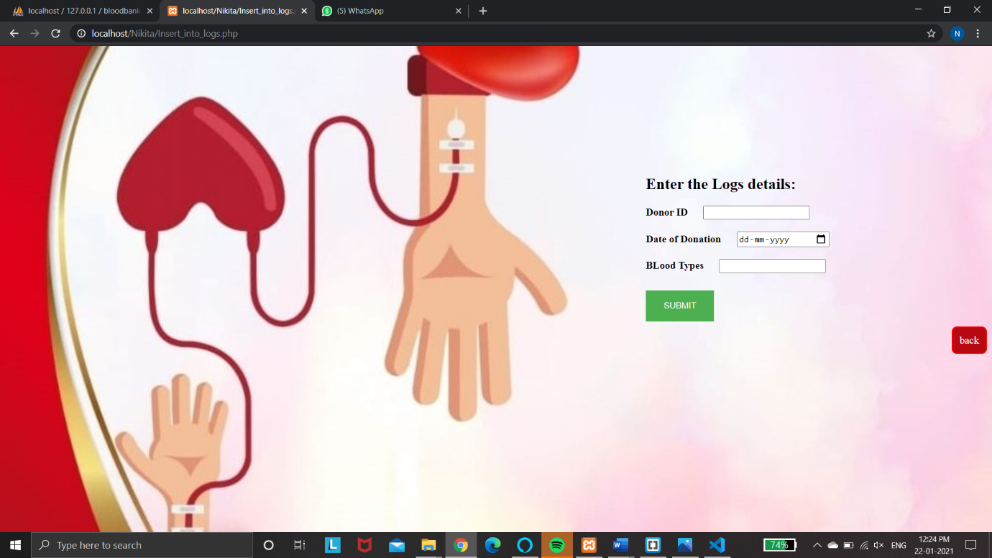

Display log Details:

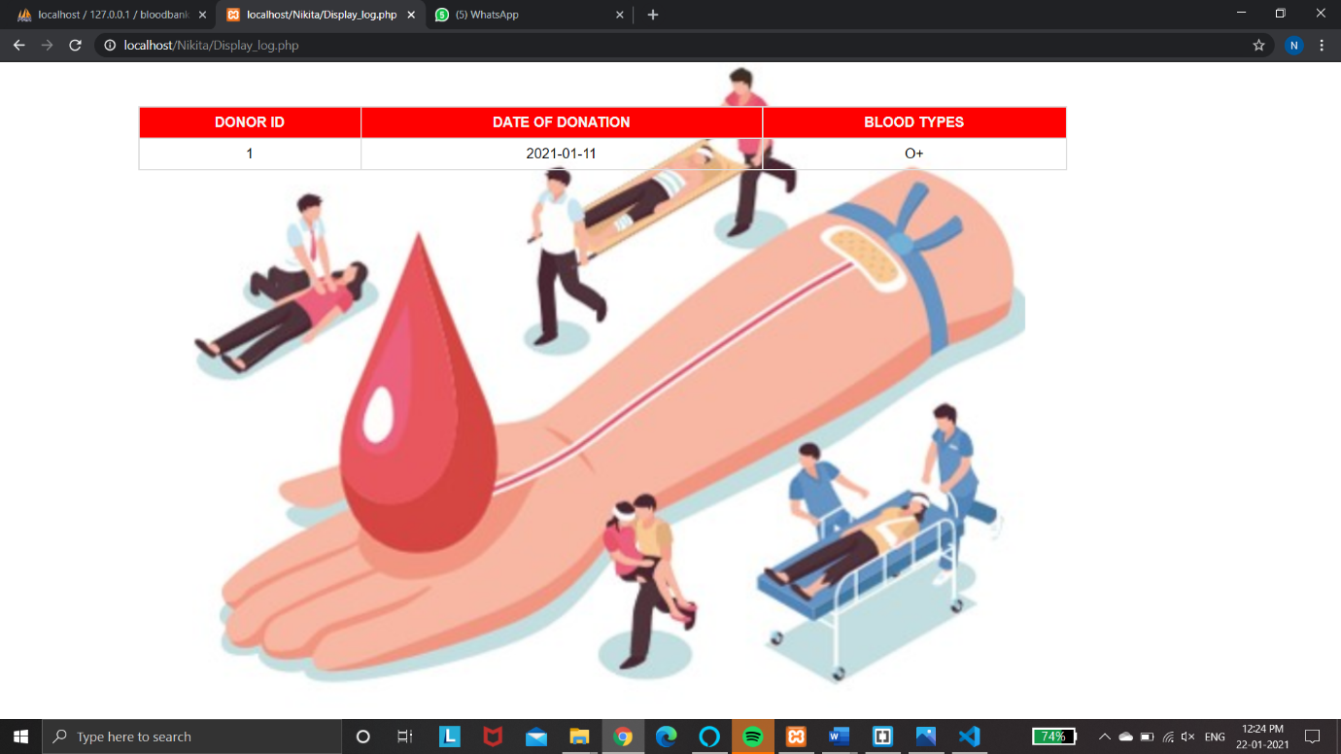

Hospital details:

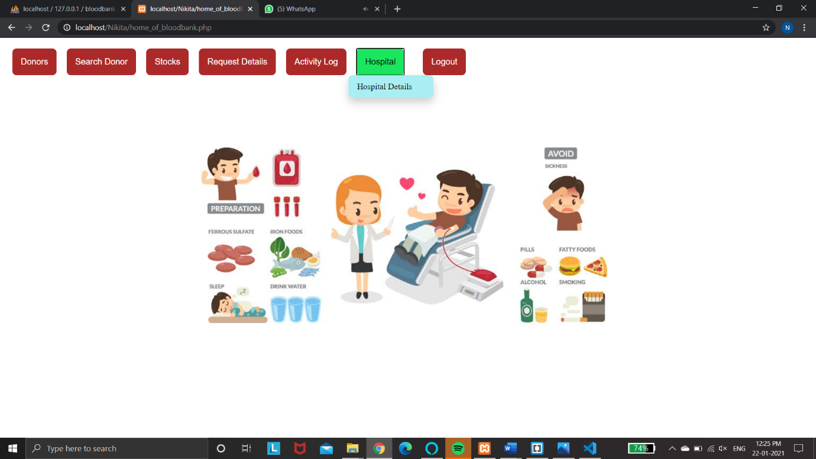

Display log Details:

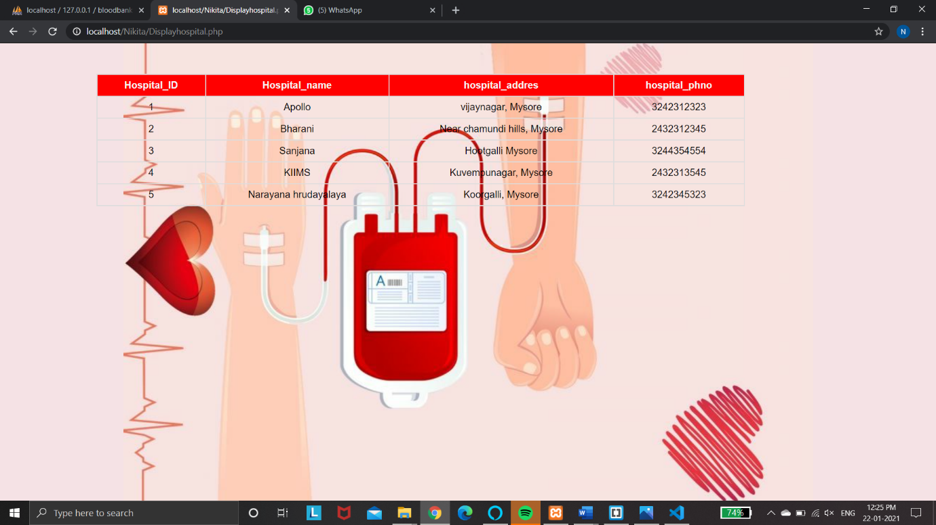

Hospital login page:

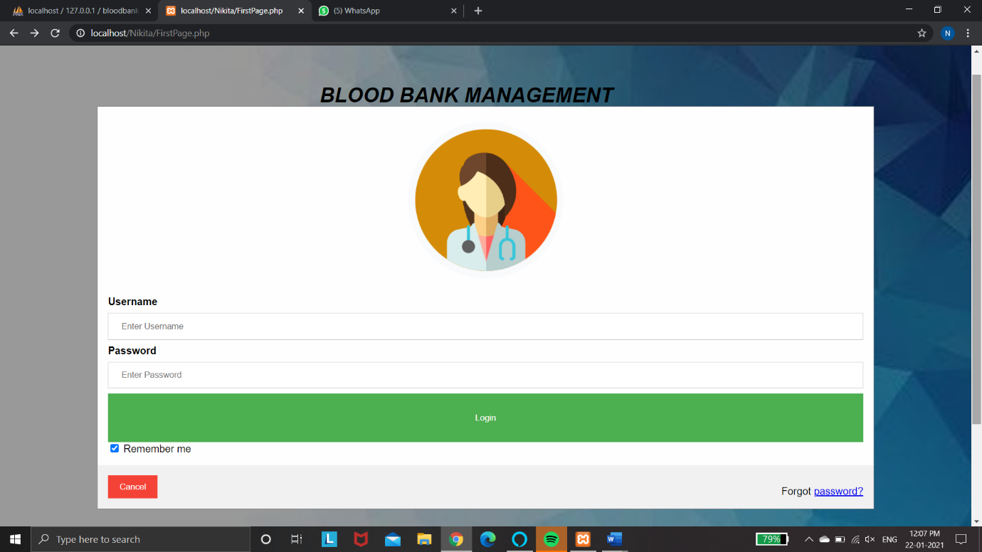

To request blood from hospital:

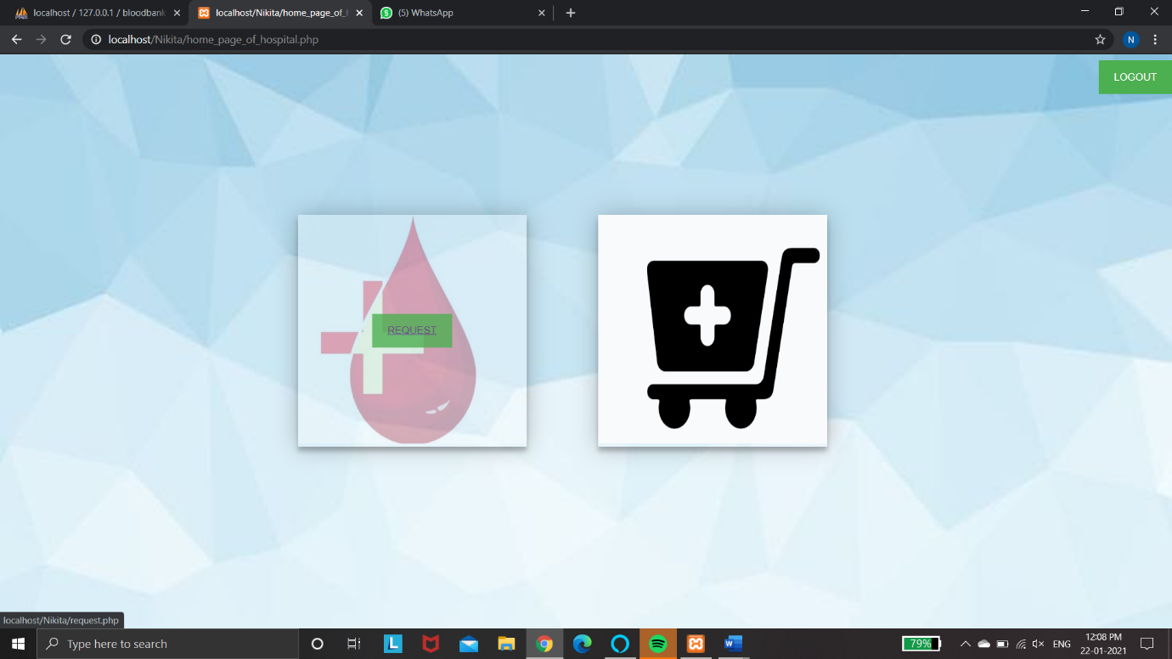

To request blood to blood bank:

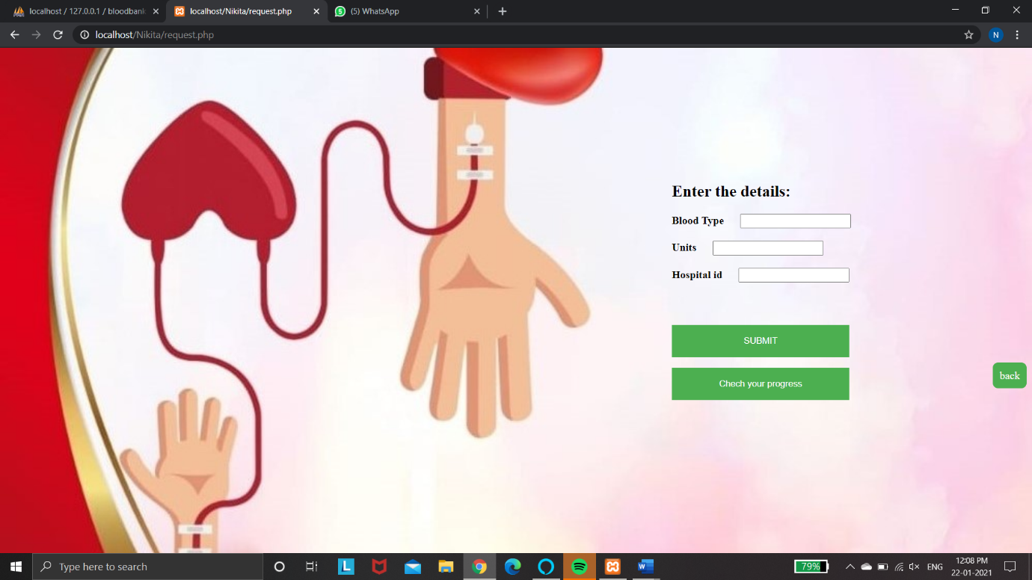

Check request progress:

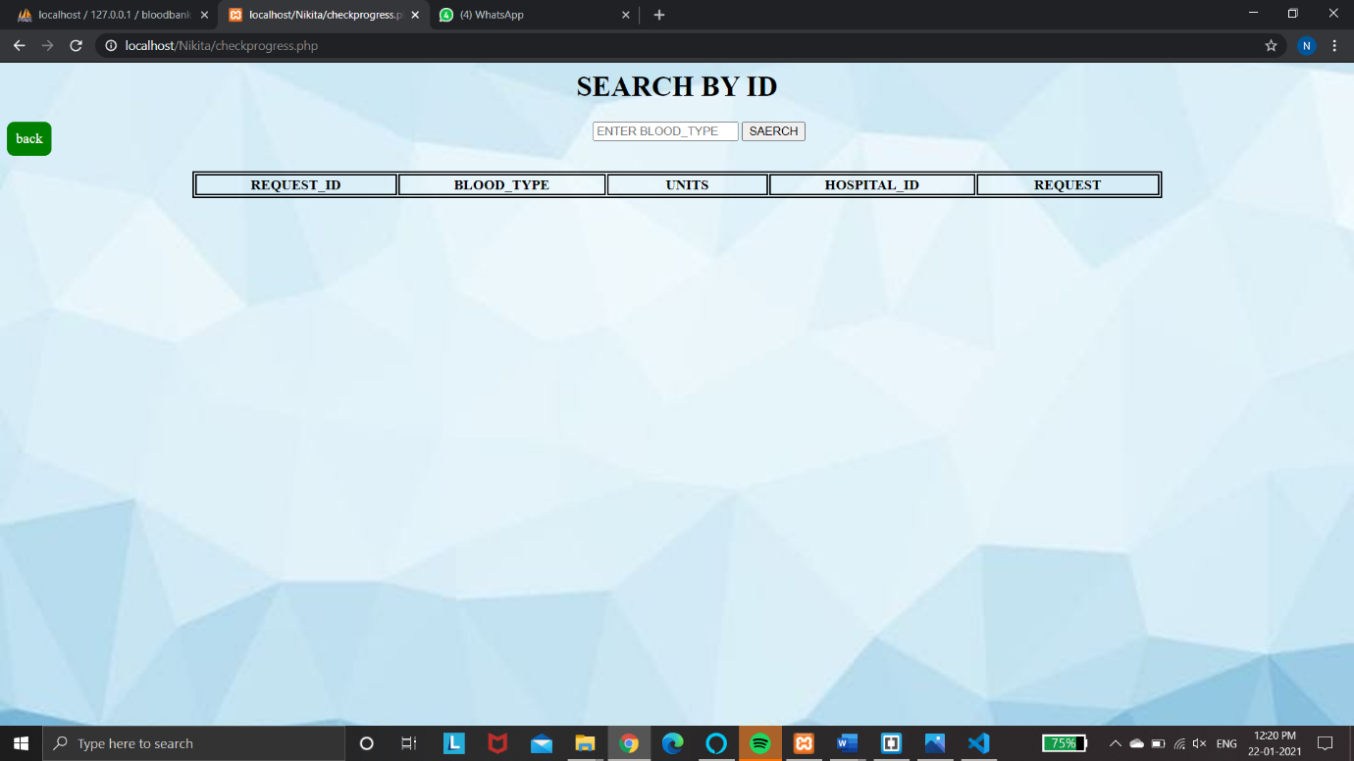

To check the stocks:

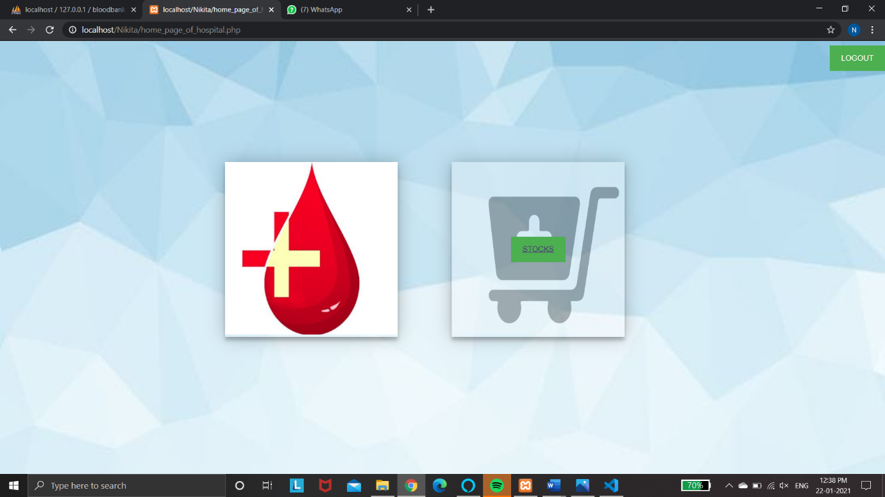

Display stocks:

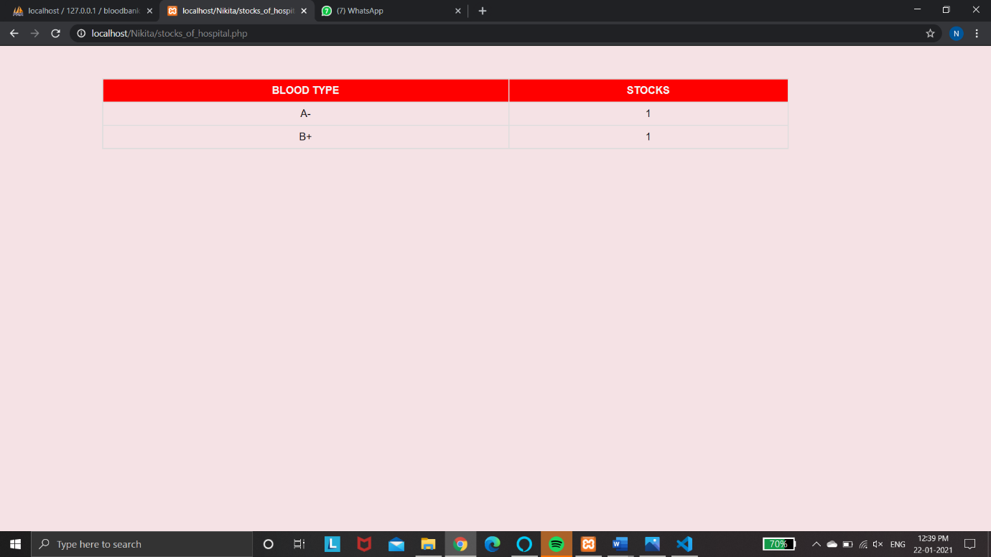

**Chapter 6**

**Conclusion**

Our project plays a vital role in storing the information about blood and donor. It helps in the retrieval of data stored about blood and doner. BBMS is a management system that is developed to manage blood bank. The BBMS had been developed in accordance to user requirement. This is to make sure that the management of the blood stock became effective, systematic and meeting user requirements. The functional services provided in the current version are profile management, blood stock management, and blood analysis management.

**6.1 BIBLIOGRAPHY**

**Books:**

[1] Database Systems Models, Languages Design and Application Programming, RamezElmasri and Shamkant B. Navathe, 7th edition, 2017, Pearson

[2] Database Management systems, Ramakrishanan and Gerkhe, 3 rd edition, 2014, McGrawhill

**Websites:**

* [**https://en.wikipedia.org/wiki/Blood_bank**](https://en.wikipedia.org/wiki/Blood_bank)
* [**https://lbsitbytes2010.wordpress.com/2013/09/24/er-diagram-of-blood-bank-management-systems5-cs2-rno12/**](https://lbsitbytes2010.wordpress.com/2013/09/24/er-diagram-of-blood-bank-management-systems5-cs2-rno12/)
* [**www.youtube.com**](http://www.youtube.com)